RADIAN - RADar-based Intelligent Activity moNitoring
Matthew Blackwell
Mitch Hoffman
Wyatt Johnson

Subsystem Reports

Subsystems Report
for
RADIAN

Team 60

Approved by:

_____________________________
Matthew Blackwell Date

_____________________________
Prof. Jang Date

_____________________________
Roman Venegas Date

Change Record
Rev. | Date | Originator | Approvals | Description
1 | 11/28/2025 | Matthew Blackwell |  | Original Release

Table of Contents
Table of Contents 3
List of Tables 5
List of Figures 6
1. Introduction 7
2. Power Subsystem Report 8
2.1. Subsystem Introduction 8
2.2. Subsystem Details 8
2.2.1. Batteries and Storage 8
2.2.2. Charging 8
2.2.3. 5 V Conversion and Distribution 9
2.2.4. Loads and Estimated Current Draw 9
2.3. Subsystem Validation 10
2.3.1 Boost Converter Design Simulations 10
2.3.2 Benchtop Measurements 12
2.4. Subsystem Conclusion 13
3. mmWave Radar Subsystem Report 14
3.1 Subsystem Introduction 14
3.2 Subsystem Details 14
3.2.1 Hardware Platform and Radar Configuration 14
3.2.2 UART Communication Architecture 14
3.2.3 TLV Frame Parsing and Point Cloud Extraction 14
3.2.4 Integration With the Data Subsystem 14
3.3 Subsystem Validation 15
3.3.1 Functional Testing With Live Radar Data 15
3.3.2 Configuration File Testing 15
3.3.3 TLV Parsing Verification 15
3.3.4 Edge Case Testing 15
3.4 Subsystem Conclusion 15
4. Mobile Application Subsystem Report 16
4.1 Subsystem Introduction 16
4.2 Subsystem Details 16
4.2.1 Application Architecture 16
4.2.2 Gotify Integration and Real Time Alerts 16
4.2.3 Fall Log Feature and Local Database 16
4.2.4 Theming and User Interface Experience 17
4.3 Subsystem Validation 17
4.3.1 UI and Workflow Testing 17
4.3.2 Alert Handling and Simulation Testing 17
4.3.3 Database Structure Verification 17
4.3.4 Stability and Performance Testing 17
4.4 Subsystem Conclusion 17
5. Notification Server Subsystem Report 18
5.1 Subsystem Introduction 18
5.2 Subsystem Details 18
5.2.1 System Architecture 18
5.2.2 Server Platform 18
5.2.3 Raspberry Pi Integration 18
5.3 Subsystem Validation 19
5.3.1 Server Deployment and Connectivity Testing 19
5.3.2 Message Publishing and Payload Validation 19
5.3.3 Stability and Performance Testing 19
5.4. Subsystem Conclusion 19
6. Artificial Intelligence Subsystem Report 20
6.1 Subsystem Introduction 20
6.2 Subsystem Details 20
6.2.1 System Architecture 20
6.2.2 Machine Learning Model Design 20
6.2.3 Fall Detection Algorithm 21
6.2.4 Raspberry Pi Integration 21
6.3 Subsystem Validation 21
6.3.1 Model Training and Functional Verification 21
6.3.2 Edgecase Generation 22
6.3.3 Frame Classification and Fall Logic Validation 22
6.3.4 Stability and Performance Testing 22
6.4. Subsystem Conclusion 22

List of Tables
Table 1: Estimated Current Draw of RADIAN System…………………………………………..7

List of Figures
Figure 1: Functional block diagram of the power subsystem ………………………………… 8
Figure 2: steady-state output voltage of the TPS61022 at nominal load …………....…….. 10
Figure 3: TPS61022 Vout vs Time and Vin vs Time………………………………………..… 11
Figure 4: TPS61022 Vout vs Time and Iout vs Time during load transient simulation……..11
Figure 5: TPS61022 Vout vs Time and Iout vs Time during input-voltage transient simulation……………………………………………………………………………………………12
Figure 6: Voltage of batteries vs Time (s) while charging……………………………………..13

Introduction
The RADIAN system is a radar-based fall-detction device that is designed to autonomously monitor activity in indoor living spaces and then notify caregivers when a high-risk individual person falls. The system collects data via a mmWave radar and uses a machine-learning algorithm to determine if a fall has occurred. After a fall has occurred, the Raspberry Pi will deliver an alert to a mobile application through a notification server. RADIAN is organized into the Power, mmWave Radar, Artificial Intelligence (Data), Notification Server, and Mobile Application subsystems, each with defined roles and interfaces. Every subsystem was validated to meet its requirements. Through this validation, a clear path to full integration into the complete system defined in the ConOps, FSR, and ICD documents will be possible.

Power Subsystem Report

2.1. Subsystem Introduction
The RADIAN power subsystem is designed to provide a stable 5 V supply to the Raspberry Pi 3 and the TI AWR6843ISK mmWave radar evaluation board. The subsystem will utilize 18650 rechargeable Li-ion batteries that will be recharged via a 5 V barrel jack. This will allow the system to be placed in any location and not depend on wall outlets for power.

The goals of the power subsystem are to deliver a regulated 5 V rail with sufficient current for the Raspberry Pi and radar. Safely charge and protect the Li-ion battery pack. Protect the rest of the system from faults (over-voltage, short circuit, reverse polarity). Provide several hours of runtime from the battery alone.

The power subsystem was tested to confirm its stability, load capability, and basic safety functions. These tests help verify that the subsystem will reliably support the Raspberry Pi and the mmWave radar of the RADIAN system.

2.2. Subsystem Details
A simplified block diagram of the subsystem is below.
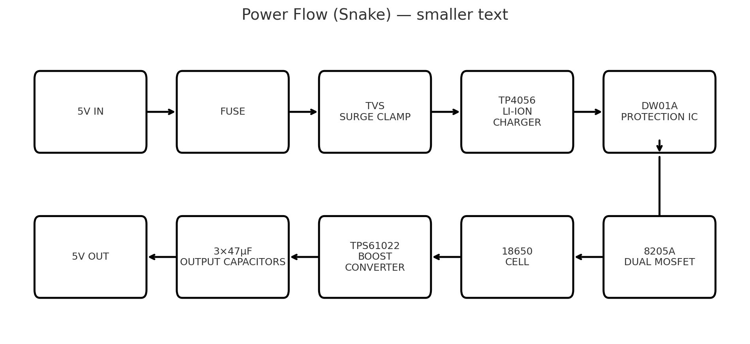
Figure 1: Functional block diagram of the power subsystem

2.2.1. Batteries and Storage
The power subsystem uses two 18650 Li-ion cells (nominal 3.7 V) in parallel to have a total capacity of 6800 mAh. A dedicated protection circuit (DW01A + dual MOSFET pack) provides over-charge, over-discharge, and over-current protection at the cell level. The total stored energy is based on the two 3400 mAh cells in parallel, which provide roughly 25.2 Wh of usable energy at 3.7 V nominal.

2.2.2. Charging
A single-cell Li-ion charger IC (TP4056) is used to charge the two batteries from a 5 V barrel jack input. The charger regulates the charge current to a safe level for the cells and will terminate the charge when the battery reaches 4.2V. The design supports up to 2 A input currents. The charger IC will charge the two batteries at a constant current of 1 A. Although it is not recommended to charge and use the system due to inefficient charging of batteries, the system can operate while the batteries are charging.

2.2.3. 5 V Conversion and Distribution
A synchronous boost converter (TPS61022) steps the battery voltage from 3.0-4.2V up to a regulated 5 V system rail. The boost converter and board layout are designed for a constant output current of 2-3 A, with short-term peaks above the current limit for inrush or transient loads. For output filtering, there are 3, 47𝜇F ceramic capacitors that help reduce ripple and prevent the 5 V rail from sagging during sudden load increase, such as Raspberry Pi boot or radar startup.

Before finalizing the boost converter design, the TPS61022 circuit was created and analyzed using TI’s WEBENCH design tool. WEBENCH was used to select all the necessary components to allow for a 5V, 2-3 A output from a 3.0-4.2V Li-ion input. The simulations that were run provide an estimated efficiency, output ripple, and component stress, which were used to confirm that the boost design could supply the necessary load currents before building the hardware.

2.2.4. Loads and Estimated Current Draw
The primary 5 V loads of the RADIAN system are the Raspberry Pi 3, TI AWR6843ISK mmWave radar evaluation board, and charging status LEDs. The table below shows the approximate current draw for each component.

Component | Voltage | Typical Current Draw | Notes
Raspberry Pi 3 | 5 V | 0.35-0.95 A | 0.35 A idle, up to 0.95 A under 400% CPU load
AWR6843ISK mmWave Radar | 5 V | 0.4-0.8 A (estimated) | Typical current from documentation
Status LEDs | 5 V | <10mA | Calculated based on the series resistor
Table 1: Estimated Current Draw of RADIAN System

Under normal operation of the Raspberry Pi and TI mmWave radar, the total average current is around 1.0-1.8 A, with short peaks on start-up or heavy computations. The boost converter, layout, and connector sizing were selected to comfortably support these loads.

Using the 25.2 Wh battery pack calculation and assuming around 85-90 % efficiency in the boost converter, a continuous 5 V load of roughly 1.5 A (7.5W) corresponds to a runtime of 2.8-3 hours. Actual runtime will vary depending on how heavily the Raspberry Pi and radar are used.

2.3. Subsystem Validation
The RADIAN power subsystem was validated through a series of simulations and benchtop tests to validate the boost converter, charger, and protection circuits, as well as to verify that the system can reliably power the Raspberry Pi and radar.

2.3.1 Boost Converter Design Simulations
Prior to building the hardware, the boost converter design was validated using various simulations in TI’s WEBENCH design reports.

2.3.1.1 Steady-state analysis
This simulation verified that the TPS61022 was capable of maintaining a regulated 5 V output over the expected input range and load currents while also staying within an acceptable output ripple and inductor/capacitor stress limits.

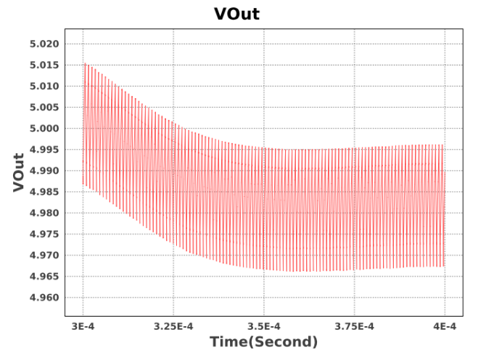
Figure 2: steady-state output voltage of the TPS61022 at nominal load

Figure 2 shows the 5 V output voltage versus time at nominal load. The x-axis is time (seconds), and the vertical axis is VOUT (volts). The red band represents the output ripple around 5 V. We can see that VOUT remains between 4.8 V and 5.01 V, showing a stable, well-regulated output.

2.3.1.2 Startup analysis
This simulation verified that the TPS61022 could start up cleanly under load without having excessive overshoot on the 5 V rail. This will help understand the boost converter capabilities when the Raspberry Pi and TI mmWave radar are connected to the power board.
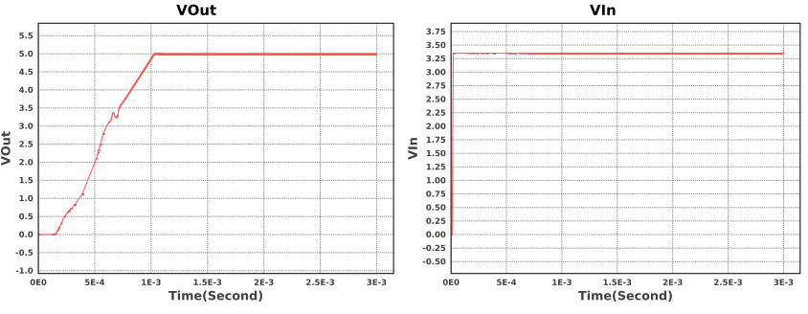
Figure 3: TPS61022 Vout vs Time and Vin vs Time

Figure 3 shows the simulated startup behavior of the TPS61022. The left graph shows VOUT rising from 0 V to ~5 V in about 1ms with almost no overshoot. The right graph shows VIN remaining nearly constant at about 3.4 V during this time. These figures confirm that the converter starts up quickly and smoothly with little to no voltage spikes on the 5 V rail.

2.3.1.3 Load-transient analysis
This simulation verified that the TPS61022 5 V output response to step changes in current, similar to the Raspberry Pi and TI mmWave radar switching between idle and active states.

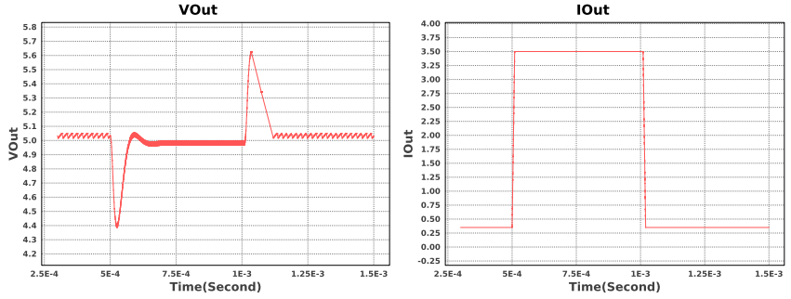
Figure 4: TPS61022 Vout vs Time and Iout vs Time during load transient simulation

Figure 4 (left graph) shows the simulated 5 V output voltage during a load step, and (right graph) shows the corresponding output current. The load current steps form ~0.3 A to ~3.5 A and then back down to ~0.3A. This step causes a brief overshoot and undershoot on the 5 V rail. In both cases, the output quickly settles back to ~5 V, showing that the converter can handle rapid changes in load without large or long-lasting spikes on the supply.

2.3.1.4 Input-transient analysis
This simulation verified that the TPS61022 could handle the input voltage changing rapidly, emulating the changes in battery voltage, i.e., changing the battery cells.
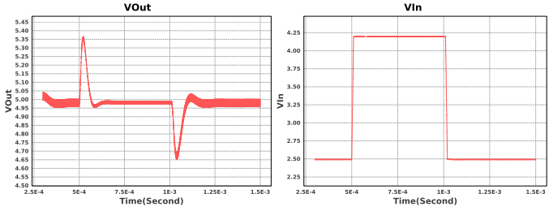
Figure 5: TPS61022 Vout vs Time and Iout vs Time during input-voltage transient simulation

Figure 5 (left graph) shows the simulated 5 V output voltage, and (right graph) shows the corresponding input voltage. In the simulation results, Vin steps from ~2.5 V to ~4.25 V and then back down to ~2.5V. As Vin changes, Vout shows brief spikes before quickly returning to its steady 5 V output. This shows that the converter maintains regulation on the 5 V rail even when the battery voltage changes suddenly.

2.3.2 Benchtop Measurements
After validating the design, the RADIAN power subsystem was assembled and tested. These tests were used to verify that the hardware meets the design goals for output regulation, load capability, and safe battery charging.

2.3.2.1 Voltage and Current Testing
The first tests were performed with no load on the output. With no external load connected, the boost converter output measured approximately ~5.03V.

During operation, an unknown amount of current caused a high-current thin trace between the inductor and the TPS61022 switching pin to overheat and open. This is not due to the TPS61022 limitations, but the copper trace design being too thin (5 mil). The failure was noted, and future revisions will increase the trace width to increase current limits. Due to this flaw, load testing was not extensively tested to ensure a fully functional board before the demo.

2.3.2.2 Raspberry Pi load test
After completing resistive load testing, the power board was connected directly to a Raspberry Pi 3 to confirm that the subsystem was capable of powering a real digital load. The Pi booted while the 5 V rail was measured using a digital multimeter. During the boot, the measured voltage remained at a constant ~4.92V. This is well within the range that the recommended voltage stays at for the Raspberry Pi.

2.3.2.3 mmWave Radar load test
The TI AWR6843ISK mmWave radar was not directly connected to the power board during testing. Because this board is shared with another member’s subsystem and there was limited time remaining before the final demo, we chose not to risk damaging the radar board.

2.3.2.4 Charger and battery behavior
The TP4056 charging circuit was tested by connecting two semi-discharged 18650 batteries in parallel to the board and applying a 5 V input at the barrel jack. The charge-status LED indicators on the TP4056 behaved as expected (red LED on when charging, green LED on when charging is complete). Below are the voltage results of the two batteries recorded over 4 hours and 44 minutes.
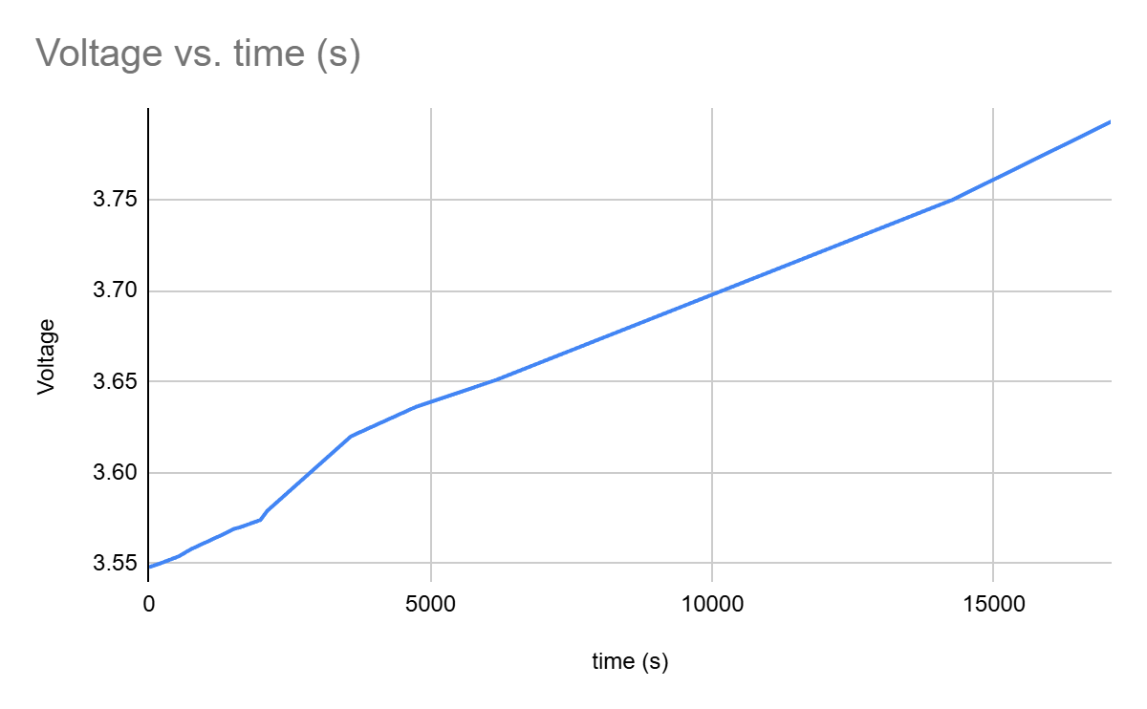
Figure 6: Voltage of batteries vs Time (s) while charging

Analyzing Figure 6, we can see that the 18650 batteries are reliably charging. While the charge time is long, this is expected since the battery's total capacity is 6.8Ah.

During charging, the boost circuit output was measured at ~5 V while the batteries were charging. Even though this mode is less efficient at charging the batteries and is not recommended for system use, no heating or instability issues were observed during these tests.

2.3.2.5 Audible alarm
In the FSR and ConOps, a local audible alarm is planned but not yet implemented. This will be implemented from January to May.

2.4. Subsystem Conclusion
Overall, the WEBENCH simulations and physical measurements show that the RADIAN power subsystem meets the core 5 V regulation and Pi load requirements. The boost converter maintains stability across the expected range, the charger safely charges the Li-ion batteries, and the hardware can power a Raspberry Pi 3 reliably. This validated the performance of the power subsystem and provided confidence that the RADIAN system will have a reliable and stable power supply, while also providing valuable layout and protection improvements for future revisions.

mmWave Radar Subsystem Report

3.1 Subsystem Introduction
The mmWave Radar Subsystem is responsible for detecting human presence, monitoring motion, and identifying potential fall events within the RADIAN system. This subsystem uses the Texas Instruments AWR6843ISK radar and a custom Python based UART processing pipeline to extract real time point cloud data. The subsystem serves as the primary sensing module for fall detection and provides the Raspberry Pi Data Subsystem with continuous spatial and velocity information needed for classification algorithms.

3.2 Subsystem Details

3.2.1 Hardware Platform and Radar Configuration
The subsystem uses the TI AWR6843ISK, a 60-64 GHz FMCW mmWave radar supporting range, Doppler (velocity), and angle estimation. A configuration file (.cfg) generated from TI’s mmWave Visualizer defines the chirp parameters, sampling settings, and processing chains for indoor monitoring. The Python pipeline automatically transmits this configuration to the radar during initialization, ensuring the sensor operates in a mode suitable for fall detection.

3.2.2 UART Communication Architecture
The subsystem uses two UART channels, a command line interface UART operating at 115,200 baud for sending configuration commands and a high speed data UART operating at 921,600 baud for receiving binary radar output. The mmwave_run.py script establishes and manages both ports, transmits the full configuration file, and maintains continuous monitoring of incoming radar data. This arrangement enables the radar to receive initialization commands and deliver live measurement data without interruption.

3.2.3 TLV Frame Parsing and Point Cloud Extraction
The radar outputs its processed data in a binary TLV (Type-Length-Value) format. The Python pipeline reads these TLVs, identifies the “Detected Points” section, and converts the spherical radar measurements into x, y, and z coordinates, along with velocity values derived from Doppler frequency shifts. The script formats each frame as a separate JSON object using NDJSON formatting, which simplifies integration with downstream software by keeping the data stream clean and machine readable while ensuring debug output remains isolated on STDERR.

3.2.4 Integration With the Data Subsystem
The radar subsystem is designed to integrate with the Raspberry Pi Data Subsystem. Although it currently operates independently for testing and development, it will eventually run on the Raspberry Pi, continuously streaming JSON formatted point cloud data to the data processing modules. This real time stream will support AI based fall detection algorithms and enable the collection of presence, motion, and velocity information.

3.3 Subsystem Validation

3.3.1 Functional Testing With Live Radar Data
Validation involved operating the radar in indoor environments and confirming that the system correctly identified stationary users, tracked walking motion, and captured rapid movements associated with fall simulations. Real time output in the terminal verified that the TLV frames were being interpreted correctly and that the point cloud data remained stable and continuous.

3.3.2 Configuration File Testing
Multiple radar configuration profiles were evaluated to ensure the pipeline operated correctly across different modes. These included short range and medium range indoor profiles. Each configuration produced expected point cloud characteristics, such as consistent frame rates and appropriate numbers of detected points.

3.3.3 TLV Parsing Verification
TLV parsing was validated by monitoring the decoded header fields, TLV counts, and detected point quantities produced by the Python script during live testing. The reported packet lengths and number of TLVs consistently matched the expected structure defined by the TI AWR6843ISk data format. In addition, the point cloud output behaved as expected when a person stood or moved at known positions relative to the radar.

3.3.4 Edge Case Testing
The subsystem was tested under various conditions, including empty rooms, cluttered environments, multiple moving subjects, and different mounting angles for the radar. In each scenario, the pipeline maintained stable operation and produced valid JSON frames without crashes or distorted output.

3.4 Subsystem Conclusion
The mmWave Radar Subsystem successfully demonstrated reliable point cloud data, TLV frame parsing, and UART based communication using the AWR6843ISK platform. Testing confirmed that the radar pipeline consistently produced accurate spatial and velocity data suitable for fall detection algorithms, and the subsystem remained stable across various operating conditions. Although system level integration is still forthcoming, the radar subsystem has been fully developed and validated in isolation, confirming its readiness for incorporation into the complete RADIAN sensing pipeline.

Mobile Application Subsystem Report

4.1 Subsystem Introduction
The Mobile Application Subsystem provides caregivers an interface for the RADIAN system and plays a central role in delivering fall alerts, presenting system status, and maintaining historical event records. Developed using Flutter for Android devices, the application incorporates a modular, tab based architecture that separates alert handling, historical logging, settings configuration, and system monitoring into distinct, intuitive interfaces. The subsystem is designed to integrate with the RADIAN backend through a Gotify server, enabling real time delivery for fall notifications generated by the mmWave radar subsystem.

4.2 Subsystem Details

4.2.1 Application Architecture
The mobile application follows a tab based navigation structure that organizes the system’s functionality across four main interfaces, the Home, Alerts, Fall Log, and Settings tabs. The Home tab displays overall system status and highlights active alerts. The Alerts tab allows users to simulate fall events and is designed to display real time alerts received from the Gotify notification server. The Fall Log tab provides caregivers with access to historical fall data and is backed by a local SQLite database implemented though Drift. This database stores fall events in a persistent on device file and supplies the Fall Log interface with structured records for review. The Settings tab enables configuration of the Gotify server endpoint and authentication token, and it also includes theme management options that let users choose between light mode or dark mode for the system’s theme preferences. These components form a modular and scalable application architecture in which the user interface, local storage subsystem, and networked alerting interface are implemented independently but designed for seamless integration.

4.2.2 Gotify Integration and Real Time Alerts
The application was designed to receive real time alerts through a Gotify server, which serves as the communication bridge between the Raspberry Pi data subsystem and the mobile device. A custom Dart service manages server configuration, authentication token storage, message parsing, and incoming alert handling. When an alert is received, the app presents a notification and initiates a recurring reminder loop that generates additional notifications every thirty seconds until the alert is acknowledged by the caregiver.

4.2.3 Fall Log Feature and Local Database
Persistent event storage is implemented using Drift, which provides a SQLite database stored locally on the device. The database maintains fall event timestamps and event source information. The Fall Log tab queries this database and displays entries chronologically for caregiver review. Although live system alerts were not yet available, the database schema and retrieval methods were validated using simulated entries, ensuring the subsystem is ready for integration.

4.2.4 Theming and User Interface Experience
The application uses Flutter’s Material 3 design system and a custom RADIAN color theme. Users may select light mode or dark mode for the app theme through controls provided in the Settings tab. UI elements were tested on multiple screen sizes to confirm consistent layout, visibility or alerts, and smooth navigation across tabs.

4.3 Subsystem Validation

4.3.1 UI and Workflow Testing
The user interface and navigation flow were validated using Android emulators to ensure that each tab behaved as intended. Simulated alerts were used to verify that the Alerts and Home tabs correctly displayed active notifications and that the acknowledgement workflows operated smoothly. Navigation between tabs, theme changes, and general responsiveness were also confirmed.

4.3.2 Alert Handling and Simulation Testing
Because there is not a system wide integration, alert validation focused on simulated fall events generated within the application. These simulations confirmed that the app could present fall alerts, highlight them in the UI, and clear them upon acknowledgement. Although real alerts from the backend were not available, the internal alert handling logic functioned correctly under test conditions.

4.3.3 Database Structure Verification
The SQLite database implemented though Drift was verified to correct creation and schema structure, but no fall events were populated through the RADIAN pipeline since the app is designed to receive entries from the Gotify server during integration. Instead, database functionality was validated by confirming that the database file was created successfully and that the Fall Log tab could render its UI elements, ensuring readiness for future integration.

4.3.4 Stability and Performance Testing
The application’s performance was evaluated under repeated simulated alerts, theme changes, and navigation interactions. The app remained stable throughout testing, with no crashes or unexpected behavior, demonstrating that the subsystem is robust and ready for integration with the radar and data subsystems once backend communication is finalized.

4.4 Subsystem Conclusion
The Mobile Application Subsystem provides a functional, stable, and modular interface for caregivers, featuring alert simulation, user-configurable settings, theme controls, and a fully implemented local database designed for future fall event logging. While full integration with the Gotify server and backend pipeline has not yet been completed, the application developed correct UI behavior, stable performance, and readiness to receive and store real alerts once system integration is finalized.

Notification Server Subsystem Report

5.1 Subsystem Introduction
The Notification Server Subsystem plays a critical role in the mission success of the RADIAN system by providing a link between the Artificial Intelligence subsystem and the Mobile Application subsystem. Utilizing the Gotify server architecture, the Raspberry Pi will be able to communicate with the server by posting fall notifications to the server in real-time, allowing for quick and very accurate detection if a fall has occurred. Once the alert has been posted, the Mobile Application will then receive the notification, allowing the caretaker to act quickly to assist the fallen individual.

5.2 Subsystem Details

5.2.1 System Architecture
The Notification Server Subsystem serves as an intermediary between both the Data pipeline and the communication between the mmWave radar and the mobile application. Once the ML model has classified each point given by the mmWave radar and then detected a fall using the fall detection logic, an alert will be sent through a Python script on the Raspberry Pi. This Python script directly communicates with the Gotify server through the local IP address of the laptop that the RADIAN team tested on. An app token was also created to allow coordination between the Python script, the Gotify server, and the RADIAN mobile application. This architecture was chosen compared to a direct device-to-device connection to allow for increased reliability, scalability, and the possibility of incorporating multiple devices through the system.

5.2.2 Server Platform
The Notification Server Subsystem is built around Gotify, a lightweight, open-sourced notification server specifically designed for self-hosted environments. Gotify was selected due to its simple user interface and implementation, vast support throughout the Raspberry Pi community, and its compatibility with local networks, specifically how it interacts with the local IP address of devices. The backend of Gotify provides high performance while maintaining low memory and CPU overhead, allowing the machine learning to run simultaneously and not interfere with the server operations.

5.2.3 Raspberry Pi Integration
The Notification Server directly integrates with the Raspberry Pi, therefore serving as both the radar processing platform and the origin point for fall alerts. A simple, lightweight Python script publishes messages to the Gotify server using the standard HTTP POST requests, the standard for server communication in many servers across the globe. The token-based authentication needed for communication between the Pi and Gotify server eliminates the need for credential exchanges, allowing for the system to be both secure and simple to deploy.

5.3 Subsystem Validation

5.3.1 Server Deployment and Connectivity Testing
The deployment and connectivity between the Raspberry Pi and the local computer were tested through a “ping” between the two devices, verifying that both systems were able to communicate with each other through the local IP address of the testing laptop. The Gotify server was also downloaded and validated through inspection when viewing the “Pip List” of downloaded libraries on the Raspberry Pi device itself. The Gotify User Interface was also tested and validated through inspection on the laptop by running the Gotify software and opening the UI on a web browser through the IP address, allowing the RADIAN team to create and share the application token needed for testing.

5.3.2 Message Publishing and Payload Validation
The message publishing to the Gotify server through HTTP POST was validated by testing the Python script made by the RADIAN team. A simple message of “Hello World” was sent from the Raspberry Pi to the Gotify server and displayed on the Gotify UI as a message from the Raspberry Pi. An additional validation test was conducted to ensure that the server was able to handle incorrect tokens, where an error message was printed showing that the message was not correctly received.

5.3.3 Stability and Performance Testing
The subsystem’s performance was evaluated under repeated communications between the Raspberry Pi and the Gotify server. No alerts were dropped when testing multiple messages in rapid succession, and when the server was restarted, the service was still stable and able to receive messages.

5.4. Subsystem Conclusion
Overall, the design and validation of the Notification Server Subsystem demonstrate that it reliably fulfills its role within the broader RADIAN architecture. The Raspberry Pi can quickly and accurately send notifications to the Gotify server, ensuring that the caregiver can receive alerts in real time and assist the fallen individual. The subsystem is now ready for integration with the Mobile Application subsystem to communicate directly with the mobile application, removing the need for an intermediary laptop device.

Artificial Intelligence Subsystem Report

6.1 Subsystem Introduction
The Artificial Intelligence Subsystem plays a central role within the Data Subsystem by determining whether a fall event has occurred using a lightweight yet robust machine-learning pipeline. A Random Forest classifier, implemented in Python using scikit-learn, is used to distinguish static versus dynamic motion using synthesized radar point-cloud data. The classifier evaluates on multiple realistic features, including additive white Gaussian noise, jitter, and small movement shifts across the x-, y-, and z-axes, ensuring reliability under realistic conditions. A Python algorithm is then utilized to detect if a fall has occurred over the last five frames of the received data, printing a message if either a fall has occurred or not, depending on the various cases that were tested. Because this subsystem directly determines whether a fall is occurring, rigorous testing and cautious tuning are essential to minimize false positives while maintaining high sensitivity to true fall events.

6.2 Subsystem Details

6.2.1 System Architecture
The Artificial Intelligence Subsystem sits at the core of the RADIAN Data pipeline, as it processes all of the incoming radar point-cloud frames and then determines if a fall has occurred. The system architecture is based on two primary components: the random forest ML movement classifier and the Python-based fall detection algorithm. The radar data is received, processed, and then classified as either static or dynamic based on a variety of factors. These classifications are then fed into the fall detection algorithm, which determines if a fall has occurred over the last five frames. This design was chosen to balance adaptability with reliability over many different types of cases. The ML classifier provides robustness against noise and irregular behavior, while the fall detection algorithm reduces the amount of false positives by enforcing physical criteria for fall motion.

6.2.2 Machine Learning Model Design
The Machine Learning model is based on scikit-learn’s random forest algorithm, as it is lightweight for the Raspberry Pi 3B+, but robust enough to resist overfitting and can handle noisy data. Because of concerns with damaging the only mmWave Radar board, a custom Python simulation pipeline was implemented to generate synthetic radar frames with varying motion patterns, Gaussian noise, jitter, and random movement shifts. The random forest evaluates dozens of different decision trees, each trained on slightly different subsets of the synthetic dataset. The result yields a stable and noise-tolerant classification between static and dynamic motion, enabling reliable performance under imperfect data.

6.2.3 Fall Detection Algorithm
Once each of the different motion states is classified, the fall detection algorithm constantly analyzes the five most recent frames to identify characteristic fall patterns. The algorithm checks for specific parameters to be true simultaneously, that the sustained dynamic movement is followed by a sudden stability and height reduction, to determine whether a fall occurred. This approach avoids any misclassifications caused by single noisy frames or any unwanted transient motions that may occur in realistic radar data. This fall detection is implemented as a lightweight Python script that runs locally on the Raspberry Pi. It displays an output message of either “Fall Detected” or “No Fall Detected” to use in the following subsystem pipeline, specifically the Notification Server Subsystem.

6.2.4 Raspberry Pi Integration
The Artificial Intelligence Subsystem is specifically designed to run on the Raspberry Pi’s limited hardware environment. The random forest is designed to be smaller to ensure that inference times will remain well below the real-time requirements of constantly analyzing the data. All of the computations, including the point-cloud processing, ML inference, and fall logic evaluation, are completed within milliseconds of each frame input. The subsystem interfaces directly with the Data pipeline, running continuously without interfering with any other processes of the Pi or the pipeline as a whole. Memory usage is kept minimal as the Data team is not using a neural network architecture, making the system even more reliable during long-term duration.

6.3 Subsystem Validation

6.3.1 Model Training and Functional Verification
The functionality of the model was tested and verified by ensuring that the random forest classifier was correctly able to distinguish between the static and dynamic motion classes. The training accuracy and confusion matrix were inspected to verify that the classifier is reliably handling the realistic datasets of noise and jitter additions. The ML model was able to report an accuracy of 89% during the demo, passing the predetermined verification plan for the random forest model. An additional verification was conducted that ran the classifier on known synthetic test frames to confirm that the output labels matched the expected labels of the test frames. As the Data team continues to develop the model, they plan to continue to increase the accuracy to a possible 95%.

6.3.2 Edgecase Generation
To validate the fall logic algorithm, the Data team generated various edgecases that may cause false positives when running the algorithm. These edge cases include sitting, bending over, kneeling, lying down slowly, trip recovery, crawling, a pet walking across the frame, an object dropping, and a hard fall. To generate these edgecases, the Data team first defined what parameters would change from normal walking dynamic frames to the edgecases and then added noise and other jitter to demonstrate realistic data. Once these cases were generated, they were trained along with the normal radar data.

6.3.3 Frame Classification and Fall Logic Validation
To validate the end-to-end operation of the subsystem, the team executed the full radar-processing pipeline, from frame preprocessing, classification, and fall detection, using the various test cases that were implemented. These test cases include normal falls, static-only scenarios, and the various edgecases generated that were mentioned in 6.3.2. For each test case, the AI subsystem printed the per-frame classification and the final fall vs. no fall decision. These outputs were then checked manually against the expected outcomes to verify the correctness of the ML model. An additional validation included intentionally corrupted frames and forcing impossible conditions to confirm that the fall detection logic failed safely without producing any false positives.

6.3.4 Stability and Performance Testing
The subsystem’s stability was evaluated by running the classifier and fall detection algorithm continuously across hundreds of frames to ensure that the inference speed met real-time requirements on the Raspberry Pi. No performance degradation, memory delays, or classification delays were detected during its extended operation during demonstration.

6.4. Subsystem Conclusion
The Artificial Intelligence Subsystem successfully demonstrates the RADIAN system’s ability to interpret radar data and determine whether or not a fall event has occurred with reliability and efficiency. Through the integration of the lightweight random forest classifier and a deterministic fall detection algorithm, the subsystem provides robust performance even under noisy conditions. These validation tests were essential in minimizing the false positives while maintaining sensitivity to true fall events. With its performance and modular design, the Artificial Intelligence Subsystem is now fully prepared for integration with the Notification Subsystem and Mobile Application Subsystem, enabling end-to-end fall detection for the overall RADIAN system.

